

Technical Report

Project Exam 1

<http://frochi.no/project-exam-1/index.html>

<https://github.com/IamMattDamon/project_exam1>

Frode Karlsen

Word count

Summary: 177 | Main text: 4378

Table of Contents

1. Summary ………………………………………………………………3

2. Body ………………………………………………………………..4-25

2.1 Introduction …………………………………………………..4

2.2 Main …………………………………………………………5-25

2.2.1 Functional Specification ……………………………..5-13

2.2.2 Research, prototype & wireframing ………….14-17

2.2.3 Design ………………………………………………………18-21

2.2.4 Programming ……………………………………………22-24

2.2.5 Implementation ………………………………………………24

2.3 Conclusion …………………………………………………..25

3. References ………………………………………………………….26

4. Appendices ……………………………………………………27-39

# 1. Summary

This is a report of Project Exam 1 for front end development at Noroff. The purpose of the project is to create a microsite for NASA or SpaceX that focuses on space technology. I will go through my process based on everything we have learned this year, including topics such as planning, functional specification, Gantt chart creation, target audience research, design process, HTML/CSS/JS, SEO, content strategy, interface design, implementation/rollout and conclusion.

I decided to create a microsite for NASA that focuses on the Hubble Telescope, which has its 30th anniversary this year. Science and technology that comes together to explore the universe is truly interesting, so I wanted to highlight the importance of the Hubble Telescope. Going through Hubble’s history through a timeline, information about launches, have cool images on display, and interaction with the community of the site was something I want to focus on.

I will take you through my process week by week, and go into further detail in each individual section of my report. Detailed description can be found in table of contents.

# 2. Body

## 2.1. Introduction

I categorized my report into five sections, which is as following:

* Functional specification
* Research, prototype & wireframing
* Design process
* Programming
* Implementation

My interpretation of the assignment was to display everything we have learned this year, as well as sharing my thoughts on the entire process through this report. I was going to create a microsite for a specific target audience through planning and research. Not much more to say, so let’s just dive in!

## 2.2. Main section of report

## 2.2.1 Functional Specification

**PLANNING PHASE**

To start with I created user stories and gave them all an ID from 1 to 26:

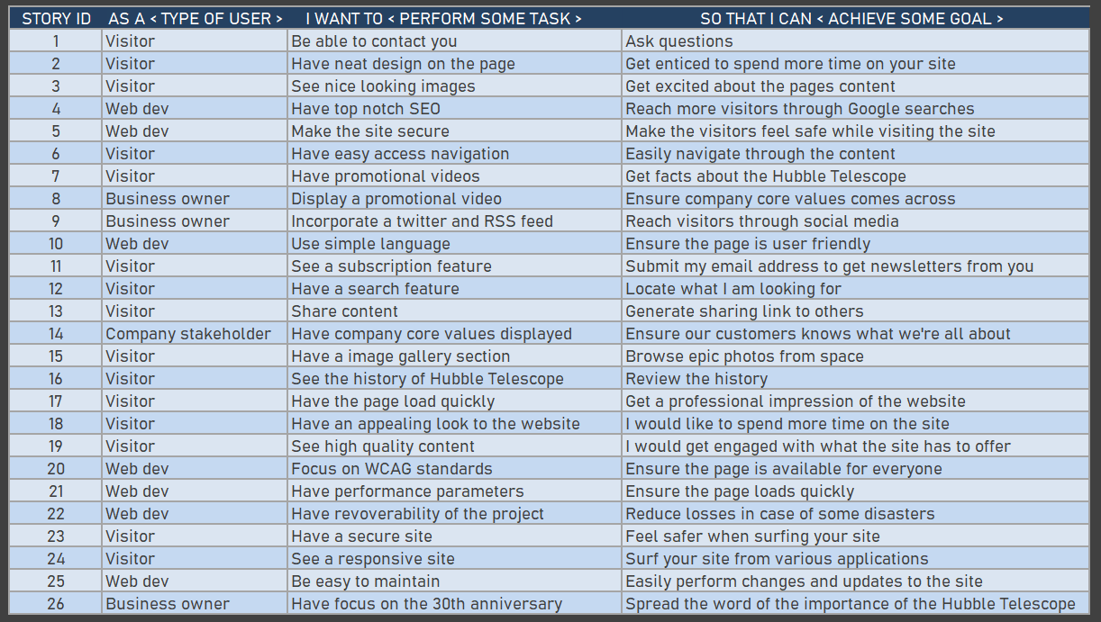

The general idea in the planning phase was to get these sorted and divided, but to keep things simple I put the development plan in four initial phases: planning phase, design phase, development phase and testing & launch. Instead of having all microtasks listed inside the Gantt chart, I decided to make them less specific in my task list, but note the smaller tasks into the ‘schedule’ section of the Gantt to describe what should be done during each task section. With that in mind I created 6 main tasks and split them up into smaller tasks into the Gantt chart:

• **Planning**: functional specification, gantt chart.

• **Research**: general research, target audience, card sorting, information architecture, personas, scenarios and storyboards.

• **Design**: general research, layouts and images, fonts and colors, navigation design and interaction design.

• **Wireframe**: wireframe creation and prototyping.

• **Programming**: research & content creation, front page (HTML&CSS base), image of the day page (HTML&CSS base), image gallery & video page (HTML&CSS base), article page (HTML&CSS base), choosing relevant API, JS coding, HTML review, CSS review, @media coding.

• **Implementation**: bugfix, user testing, rollout and report writing.

I also created a weekly schedule from week 1 to 5 and split up into daily workplan for each smaller task. Upon completion the scheduled task will get a red color when done to display progress of the project, which is displayed in the Gantt chart provided in this deliverable task.

**FUNCTIONAL SPECIFICATION**

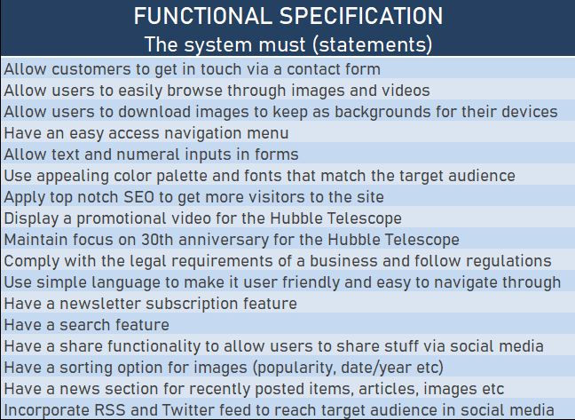

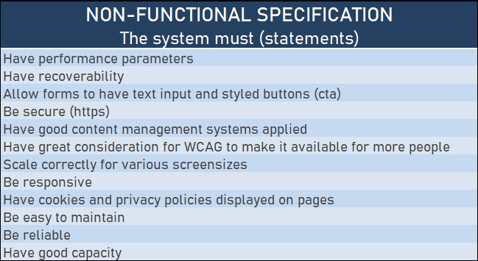

**THEMES**

**1. Hubble Telescope’s 30th anniversary**

This is the main goal of the microsite. I want a site that celebrates the 30 years of the Hubble’s existence and its unique history. The microsite will contain interesting articles, but in particular have a clear focus of the fantastic images the telescope has taken and details behind the images.

**2. Social media presence**

This is another focus area of the microsite. Here I plan to have an RSS feed on the page and twitter feed directly from NASA. Visitors are also allowed to share stunning images on their Facebook page, download images as backgrounds to their smart phones/tables/PCs and rate images. Another idea to spread the page through social media would be to have quizzes with prizes such as NASA t-shirts and other apparel.

**3. Display company core values**

NASA is all about integrity, safety, teamwork and excellence. These core values are set in stone to ensure successful missions. However, they are in the end all about exploration, curiosity and education. Their work is a study of the universe we live in and space exploration. I will focus on finding our inner child via imagination. Who hasn’t pretended to be an astronaut as a kid?

**Hubble Telescope’s 30th anniversary**

|  |  |
| --- | --- |
| FEATURE | WEBSITE DESIGN |

Epics

• As a visitor, I want an appealing website, so that I will get engaged by its content.

• As a visitor, I want engaging content, so that I will visit the site every now and then.

User Stories

• As a visitor, I want nice images displayed, so that I will get enticed to browse through the content on your website.

• As a web dev, I want a nice looking website, so that we can represent NASA in the best way possible to the public.

• As a web dev, I want a nice layout that emphasizes the most important parts of the pages.

• As a web dev, I want the company colors to shine through, so that it feels familiar to the users.

|  |  |
| --- | --- |
| FEATURE | NAVIGATION |

Epics

• As a visitor, I want a navigation menu, so that I can easily browse through your pages.

• As a web dev, I want a navigation menu, so that our website looks professional.

User Stories

• As a visitor, I want a nice looking navigation menu, so that I swiftly can browse through the various pages/sections of the site.

• As a web dev, I would like the navigation menu to include a search bar so that users can swiftly search through the pages contents.

• As a web dev, I want a hamburger menu for mobile and smaller screen resolutions, in order to maintain easy navigation on the site.

|  |  |
| --- | --- |
| FEATURE | CONTACT FORM |

Epics

• As a visitor, I want a contact form, so that I can get in touch with you in case I have any questions.

User Stories

• As a visitor, I want a contact form, so that I can get in touch with you if I have any questions or leave feedback.

• As a web dev, I would like our visitors to be able to contact us, so that we are in better touch with the customer base.

• As a visitor, I would like confirmation that the message have been sent, so that I can be notified about this.

**Social media presence**

|  |  |
| --- | --- |
| FEATURE | IMAGE OF THE DAY |

Epics

• As a visitor, I would like an image of the day section, so that I can see fantastic images every day.

User Stories

• As a web dev, I want the Image of the Day section to be available in the navigation, for easy access to our visitors.

• As a visitor, I want to be able to share and download these images, so that I can share them through social media, or use them as a background on my phone/tablet or PC.

|  |  |
| --- | --- |
| FEATURE | QUIZ |

Epics

• As a visitor, I would like a quiz section, so that I can take part on quizzes on your page.

• As a web dev, I would like to create a quiz to better interact with the visitors and entice them to come back to the site.

User Stories

• As a web dev, I would like to make a quiz for our visitors with prizes such as NASA t-shirts and apparel to spread the word about the page.

|  |  |
| --- | --- |
| FEATURE | SOCIAL MEDIA LINKS |

Epics

• As a visitor, I want easy access to social media links, so that I can easily locate NASA on social media.

User Stories

• As a web dev, I would like to provide easy to find social media links, so that visitors can review NASAs social media accounts.

**Company core values**

|  |  |
| --- | --- |
| FEATURE | PROMOTIONAL VIDEO |

Epics

• As a visitor, I would like a promotional video, so that I can see what the Hubble Telescope is all about.

User Stories

• As a web dev, I would like to have a promotional video on display, so that visitors easily can see a video what the Hubble Telescope is all about.

|  |  |
| --- | --- |
| FEATURE | HISTORY |

Epics

• As a visitor, I would like to read about the Hubble Telescope’s history, so that I can see where it all started.

User Stories

• As a web dev, I would like to give our visitors the opportunity to see the history of the Hubble Telescope through a visual timeline.

**GANTT CREATION**

As for the Gantt chart and the creation process, I simply revamped the one I created for our CA in the Project Methodology course. I changed up the colors, but as for the main structure and design it remained the same.

I put up estimations as per your example from the Project Exam Deliverables/Milestones:

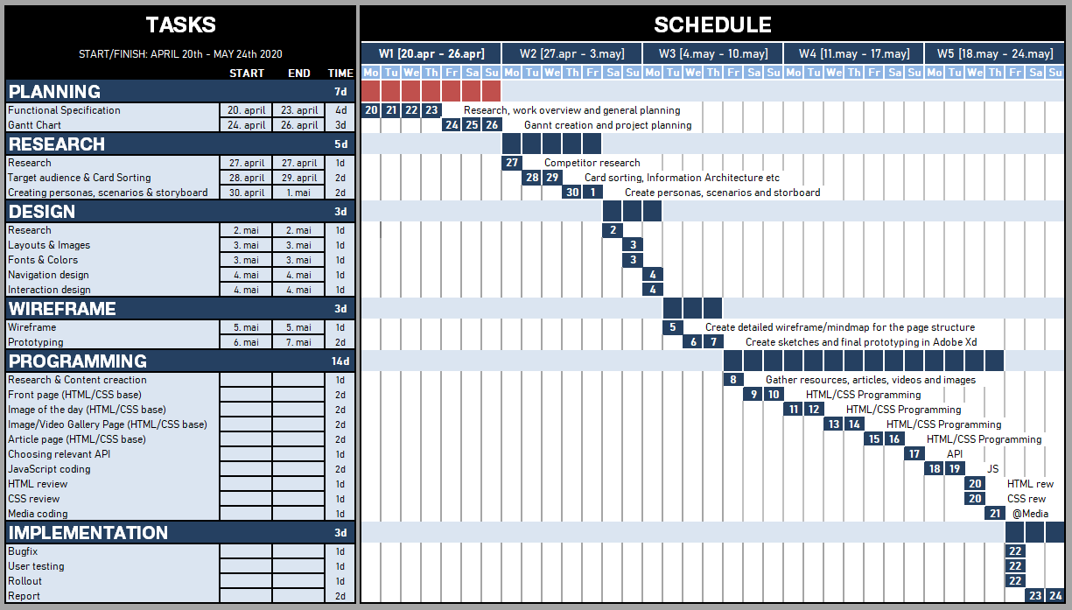

The red color inside the schedule indicates finished tasks, while the blue is unfinished tasks. This makes the project easy to follow in regards to progression. I have not taken any days off, but I usually take it slow on Monday. I also have my own birthday on the 6th of May, while my father have his on the 16th of May, so those will probably be a bit slower in terms of workload. The rest is pretty self explanatory to be honest.

Link to Gantt chart via my GitHub repo:

<https://github.com/IamMattDamon/project_exam1/blob/master/Report%20Files/functional%20spec/Gantt.xlsx>

## 2.2.2 Research, prototype & wireframing

**TARGET AUDIENCE RESEARCH**

To kick this off, I need to know who the main target audience for NASA is, but to answer that question we need to look at what NASA does. NASA is more than just astronauts. They provides careers in tons of fields such as science, engineering, IT, human resources, accounting, writing, technicians and so forth.

NASA as a company is all about exploring the extraordinary, and this is what entices their target audience. It’s something exciting, it’s the dream many had as a kid, to become an astronaut. It is about being on team earth of exploring the universe we live in. It is about teamwork in order to break barriers to achieve something seemingly impossible. They are basically dreamers that wants to explore the unknown for answers about our very existence and purpose.

So, what are we looking at here? As per their workforce, NASA consists of 72% white or Caucasians.

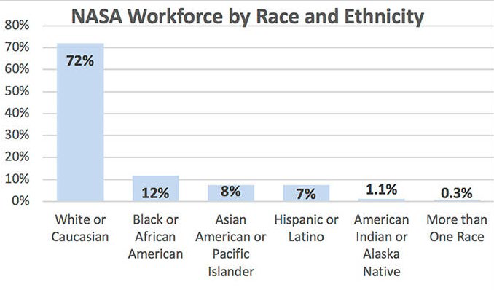

Most of NASA’s jobs are technical related and demand higher education, leaning towards a very high percentage of men. According to Google’s workforce, tech related jobs are at 83% male in terms of gender diversity, which is very high. In other words we predominately looking at men that are interested in science/tech. The age range of the target audience will be anything from kids to adults that share these interests.

**PRODUCT RESEARCH**

The journey started around 400 years ago, when Galileo turned his telescope towards the skies in 1610. We quickly learned that Saturn had wings, Jupiter had moons, the Milky Way was not a cloud but a collection of countless stars. Within a few years, our understanding of ‘our world’ would be changed forever.

In the centuries that followed, telescopes grew in size and complexity, and of course, power. In comes Edwin Hubble in 1920, from whom the Hubble Telescope is named after. He used the largest telescope available during his day in the 1920s at the Mt. Wilson Observatory to discover galaxies beyond our own.

Hubble, the observatory, is the first major optical telescope to be placed in space, the ultimate mountaintop. Above the distortion of the atmosphere, far above rain clouds and light pollution, Hubble has an unobstructive view of the universe. Scientists have used Hubble to observe the most distant stars and galaxies as well as the plants in our solar system.

Hubble’s launch and deployment in April 1990 marked the most significant advance in astronomy since Galileo’s telescope. Thanks to five servicing missions and more than 25 years of operation, our view of the universe and our place within it has never been the same.

We are looking at a great history of exploration, dreamers, aspirations, science and technical advancements. That is exactly what drives our target audience. In the end, space exploration is all about people, the human race and its journey through investigating our own existence and the world around us.

As for inspiration I looked at pages such as Hubblesite.org and NASA.gov. A lot of my external linking goes to both pages, as they have plenty of interesting content.

**PERSONAS**

I need my personas to be male Caucasians, that are basically a bit ‘geeky’. I went for Leonard and Howard from The Big Bang Theory, which fits my target group perfectly. They should be both relatable and in the target audience of the microsite (Figure-1 and Figure-2 in the Appendices).

**SCENARIOS**

The scenarios I have made are basically done to better understand our target audience, and when and how they would visit our microsite most likely. These are just simple sketches of scenarios I have made (Figure-3, Figure-4 in the Appendices).

**STORYBOARD**

My storyboard is just a simple mockup of how I want the page structure to look like (Figure-5 in Appendices). This was later changed slightly as the coding process started. Some things I was unable to implement, while the news page got redacted as I did not see it as vital to the page. I replaced this with a launch page as I figured that would be more interesting for the visitors. Rockets are kind of cool when you think about it.

**WIREFRAME & PROTOTYPE**

Figure-6, figure-7, figure-8 and figure-9 in Appendices.

The process started off by making paper sketches of wireframes for desktop. The mobile version will be a 1-column layout, so I skipped the sketches for that and focused on sketching for desktop, which will have a 3 column layout. As for the wireframe, I made pencil sketches for each of the 5 pages (home, images, video, news and contact), as you can see from the images.

Now that the sketching was done, I moved to Adobe Xd to create the prototype. I basically used the sketches as a base. The main focus area is that this is a microsite, so it will mostly be focused on engagement with NASA’s community by promoting stunning images, a cool looking design, quizzes, videos and social media links. The main idea is in the name I have chosen for the website; Hubspot – a hangout spot for people interested in the Hubble Telescope, NASA, and a celebration of its 30th anniversary.

Prototype images displayed in figure-10, figure-11, figure-12 and figure-13. Since I removed the news page I did not add this in the report. The main concept of the launch page will basically feel familiar to the rest of the site. The search bar in the navigation I had planned for was also removed during coding, as I did not really feel the page had enough content to back up the need for a search function to be present.

**CONTENT STRATEGY**

When making the prototype I included this task here, to ensure that my planned content was sorted by information architecture, or at least my own vision of what was most important according to my personas. The plan was to use the same tone of voice in terms of language on the page, use 3rd party linking, good SEO and implement interaction with a quiz to keep the users coming back to the page every now and then.

## 2.2.3 Design

**DESIGN RESEARCH**

I will take advantage of the research I’ve already done with the personas I made from the target audience research. That leads me towards the interests of my personas. My research revealed that my target audience is male, Caucasians that are interested in science and technology. Other interests of this group would be things like science fiction, comics, video games, computers, tv-shows and movies.

Fantasy seems to be a red thread of what I am looking at here. I want to capture fantasy into a color chart, the font selection, and my general design concept. NASAs design on their website looks sort of old-school in my opinion. Dark colors to make the images pop more are definitively something I will keep. So, in short I will focus on fantasy/dreams and make it look cool.

After thinking about it thoroughly, I feel that ‘cyberpunk’ is a pretty cool topic in terms of colors options and general theme. Cyberpunk refers to both a culture and a genre, but is mainly a sub-genre of science fiction that features advanced science and technology in an urban, dystopian future. Short and sweet it’s high tech and low life – a neon dystopia.

The colors you would go for are vibrant, bold and eye catching. At the same time, cyberpunk is futuristic and fits the dreamer aspect of my target audience, and it might appeal to a younger target audience at the same time with a very unique and cool look. This is sort of a unique approach. I don’t want to overdo it though, so I want to keep it a bit toned down in order to keep things professional looking, but maybe put in some flamboyant design decisions for certain aspects of the page to make things “pop”, such as images, call to action, links etc. The branding of Hubspot is supposed to be something exciting and fresh, so that is what I am aiming for with the page.

**COLOR WHEEL**

I looked up cyberpunk and images online. Here I found a few that matched my vision in terms of colors (Google search). So, I took the following image and ran it through Adobe Kuler to create my color wheel:

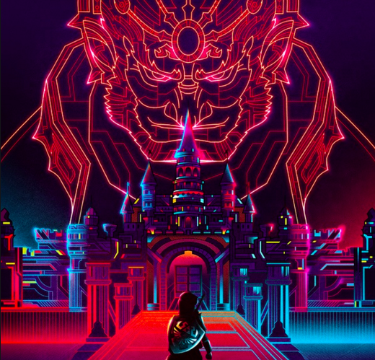

This is the color chart I created from it:

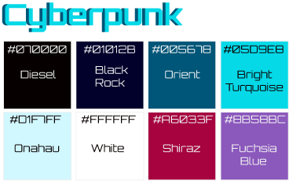

**TYPOGRAPHY**

As for my font selection I want a mix of something that screams sci-fi, and a clean looking font that is easy to read. I made some research online and found a Google font called Orbitron, which is a geometric sans-serif typeface that is intended for display purposes. Orbitron comes in four weights, so it gives me a bit of playing room in that regards. Personally I like the way it looks, as it gives me a sort of sci-fi movie poster feel, which is exactly what I looking for.

To match Orbitron I am going to use Open Sans, which is a very clean and modern sans-serif typeface. This font is highly legible and therefore will be a good counterpart to the futuristic Orbitron. That is really all I have to say in terms of my decision when it comes to typography/font selection. Huge plus that both are supported by Google fonts, which makes implementation of them nice and easy.

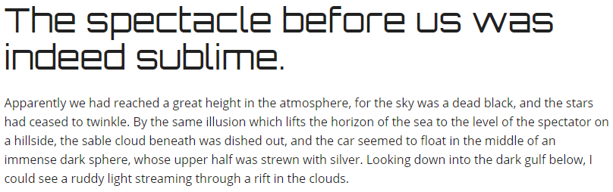

**NAVIGATION DESIGN**

For this part I am going to have to consider a good structure, good usage of white space to not make the page feel overly cluttered, and overall design.

As for the page structure, I will focus on solid information architecture, with the most important content up top, and the least important content at the bottom of each page. The navigation on each of my pages has an image (banner type image) up top. The landing page one sort of sets itself apart from the rest of them, as it’s supposed to be an interactive menu where you can browse 10 different images and download it. This will only be implemented if I am able to pull it off in terms of coding.

Looking at the rest of the pages, I am happy with the information architecture. Moving on to minimalism and use of white space, I got that nicely covered in the prototype I made. This is something I kept in mind when making the separate pages.

The only thing left is for me to make a separate page containing the launch information. I forgot to make that in the prototype for some reason, but used the other pages as a “template” to fit the bill.

In terms of overall design I will try to keep it as simple as possible. I am going to use a recognizable pattern that goes icon first, followed by a header, descriptive text, and finally a button for external/internal linking.

**HOVER EFFECTS**

I wanted to play a bit around with the hover effects, so starting at the navigation I made the color for the active page class to bright turquoise, instead of the sharp red color I had on the prototype. I also made a text shadow effect to look like a neon shine.

The buttons all have the same effect, which is a simple invert of colors with a 0.3s ease-in on hover.

## 2.2.4 Programming

**SEO**

I wanted to get this out of the way first and gave all individual pages their own description based on the contents on the page. Nothing fancy. As for keywords I took the H1, H2 tags and included them, along with Hubspot, Hubble, NASA, Technology and Science as tags. The tags reflects what each of the pages are all about, and what the target group might search on to locate each page.

I have also ensured to keep the titles short. This is pretty much all you can do without using proper tools to score higher in terms of SEO (spiders, crawlers etc).

**WCAG**

To keep with WCAG standards that are set, I ensured that my colors had clear contrast so that the content would be readable for everyone. I also ran the HTML through a WCAG checker. I sorted out the major issues, while the ones left behind are not really necessary to fix. Images have descriptive alt text, I have used HTML5 for good semantic HTML code and the structuring of my code is neat and readable.

**HTML**

As for the HTML, I have made 5 different pages (index, launch, images, videos and contact). All pages have links towards Google fonts for easy font implementation and font-awesome for the hamburger menu on smaller screens.

The structure of each page follows the same flow with the header up top, including navigation. Next I got banners on each page with an H1 tag above the banner image. H2’s have been placed in the center of the banner images, along with buttons for external links where applicable. The main part of the page has an own background. Then I have broken up each section from most important to least important from top to bottom, in order to have good information architecture.

At the bottom of each page (except contact form page) I have a footer that includes links, a newsletter subscription form and social media links. All external links have a target _blank to ensure that visitors gets the links opened up in a new window. Kind of cheeky, but it ensures that they do not leave the page when opening up external links, which is intentional. Finally, I have the script tags to JavaScript files if applicable on the page.

**CSS**

Now, this is always a tricky one for me, and this time around I tried to cut down the CSS code as much as possible. I made classes for divs that could be reused in terms of styling, so that I wouldn’t go into the same trap as I did during the Semester Project. While writing this report I can see that I have 1412 lines of CSS code with spaces between them and tags to easily find new sections/pages etc.

For help with various problems I stumbled upon I used Google and stackoverflow to find solutions to my problems. We also have been helping each other out in the Discord chat from time to time.

During the coding process I used a live server in Visual Studio Code and Chrome Dev Tools to quickly see and fix changes as I was performing them.

**JavaScript**

I had this bright idea of implementing an astronomy image of the day on the image page via the NASA API, but all I found in terms of help was people that had used React etc. on GitHub, which we really have not learned anything about. I gave up on this idea and just made an external link for this section.

As for the countdown section that I have used on the launch and landing page, I found plenty of examples online on how to build a countdown. However, none of them displayed how to solve the Math equations and date conversion when calling a specific API. The code I have used is not my own. Not really sure how to go on to make something like this, so I am just putting this under my references.

The contact form is also not my code, as I used the one provided by you from the conference call and just styled the CSS on it. I was cramped on time, so just had to do that. The same base has been used for my newsletter subscription form.

As for the launches section, I also looked at the source code from the same project as mentioned earlier, but tried to make it my own rather than just using his code here. I looked at your video of the API conference, and got plenty of help from that to keep moving. I also looked back at my CA and MA tasks, and numerous Youtube tutorial videos. Plenty of time have been wasted on missing > “ ) ; etc, but I guess that is something everyone struggles with when you go “blind” inside the code matrix.

JavaScript has been really tricky to wrap my head around, and the imposter syndrome is kind of creeping in to be honest. Not really sure if a “monkey see, monkey do” approach is the best way to learn JavaScript, but what do I know. We all have to start somewhere I guess. I am going to spend the summer to dive further into it to have a greater understanding, but I feel like I have learned quite a lot during the past 6 months.

## 2.2.5 Implementation/rollout

I double checked all links to see that they were working, and once done loaded it all up to my server via FileZilla. Once uploaded I checked the page on mobile and I used the web developer tool to view responsive layouts. It all looked great, now I just had to check the performance of the page itself, where I used gtmetrix.com. The report showed that I could save minor KiB on scaling the .png files I had used for icons. They don’t really take up that much space to be honest, so I did not use any time on that. The rest of the pages performance came out clean, so I was happy with that.

2.3 Conclusion

To conclude this report I have summed up my process on creating a microsite for NASA’s Hubble Telescope, called Hubspot. The report includes the functional specification, all the research I have done, the prototype & wireframe, the design process, thoughts and decisions, programming issues, structure and implementation.

This was truly a huge task to get done in 5 weeks, and obviously during the course of a project like this you have to stay fluid. Some things you are not able to implement, so you have to improvise or change direction. Others go as planned. In the end I am happy with what I have delivered. I think the page looks good, the site is fully responsive, loads quickly, has no major bugs, the API calls are all working and all internal/external links are working fine as well. With that said, I have learned a lot during the first two semesters at Noroff and really look forward to learn more.

# 3. References

**Newsletter form:**

<https://www.w3schools.com/howto/howto_css_newsletter.asp>

**Gradient backgrounds:**

<https://cssgradient.io/gradient-backgrounds/>

**Images.html page -> toggle menu code for 'More Images' collapsible menu taken from:**

<https://alligator.io/css/collapsible/>

**Image page -> Image gallery section. Responsive grid code taken from W3Schools:**

<https://www.w3schools.com/howto/tryit.asp?filename=tryhow_css_image_grid_responsive>

**contact-form.js -> from :**

<https://github.com/javascript-repositories/video-call-simple-form-validation-with-plain-JavaScript>

**nextlaunch.js (also inspo for launches.js) -> from:**

<https://projectexam.z16.web.core.windows.net/index.html>

**Images from:**

<https://www.nasa.org/>

<https://www.hubblesite.org/>

**Timeline created via:**

<http://timeline.knightlab.com/>

**API:**

<http://api.spacexdata.com/v3/launches/>

<http://api.spacexdata.com/v3/launches/next>

<http://api.spacexdata.com/v3/launches/upcoming>

<http://api.spacexdata.com/v3/launches/past>

# 4. Appendices

Figure 1 - [Persona: Leonard]:

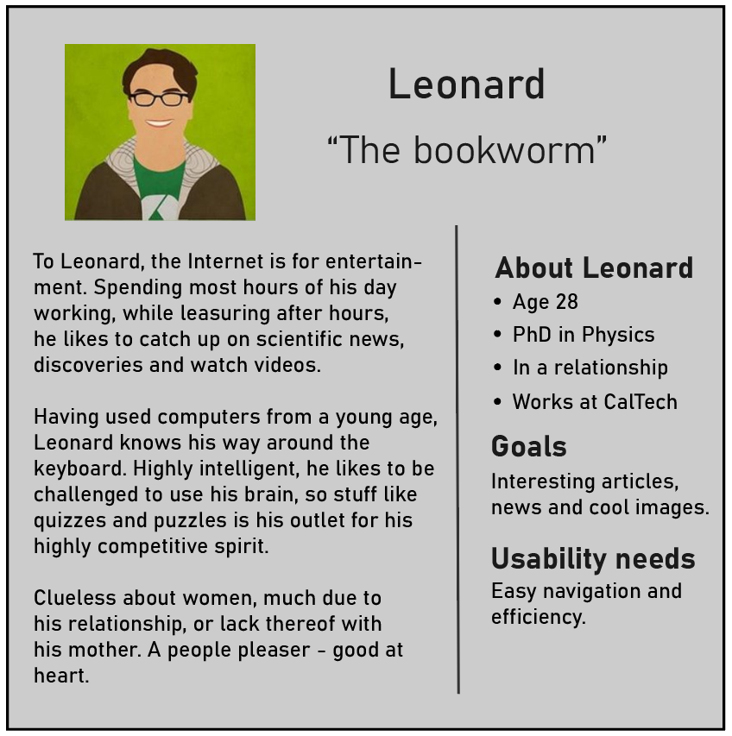

Figure 2 - [Persona: Howard]:

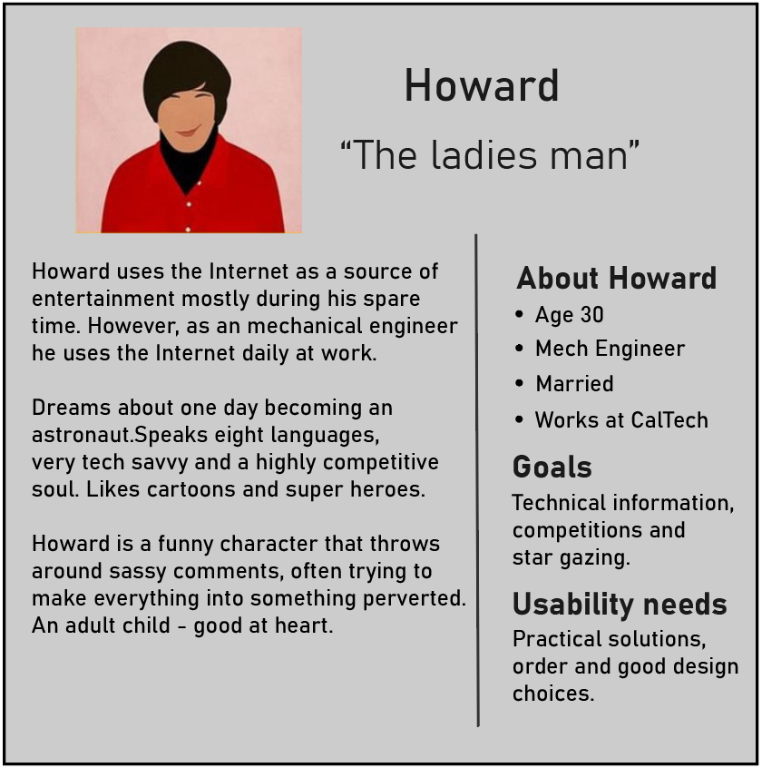

Figure 3 - [Scenario #1]:

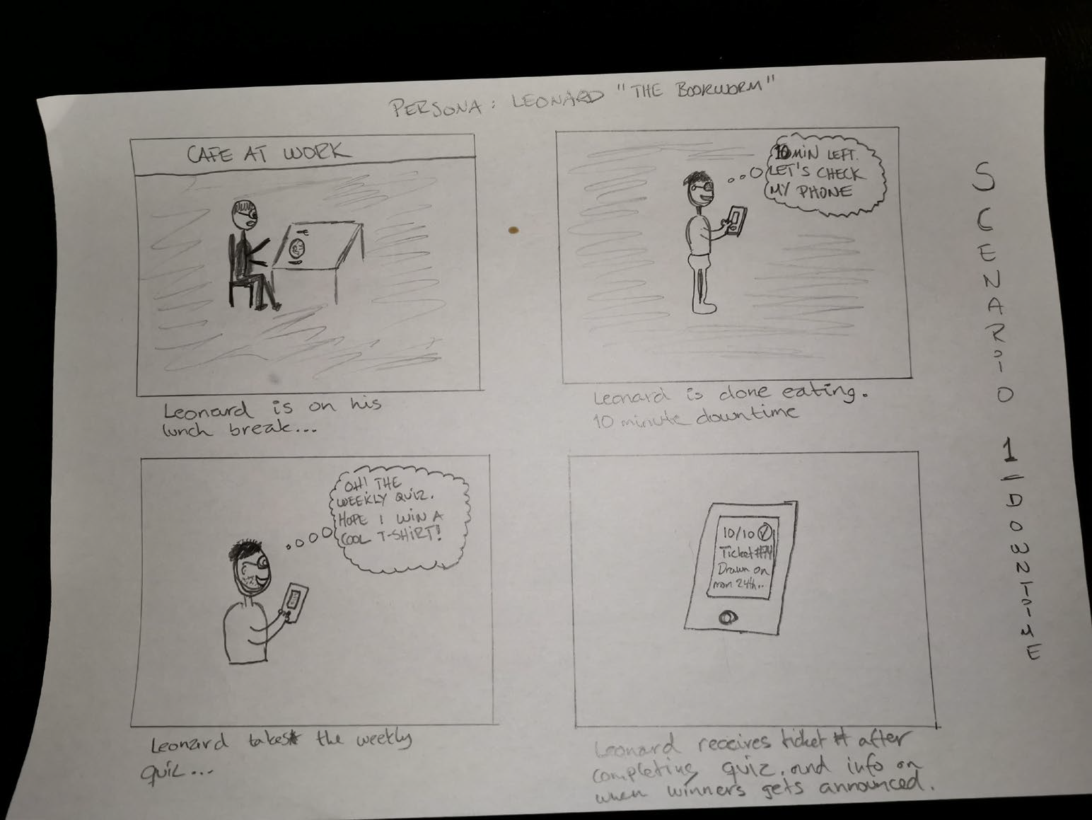

Figure 4 - [Scenario #2]:

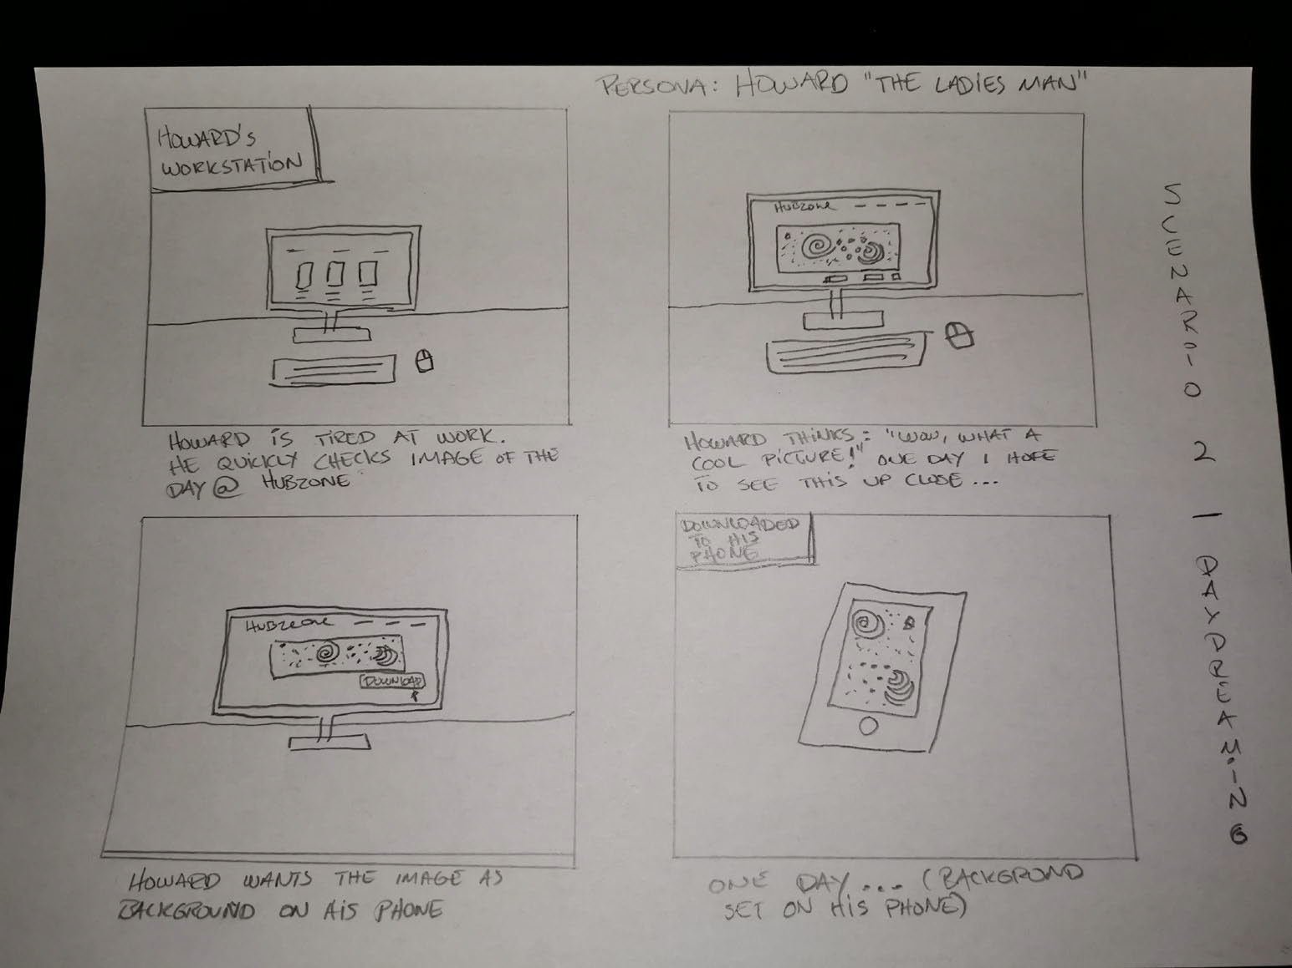

Figure 5 - [Storyboard]:

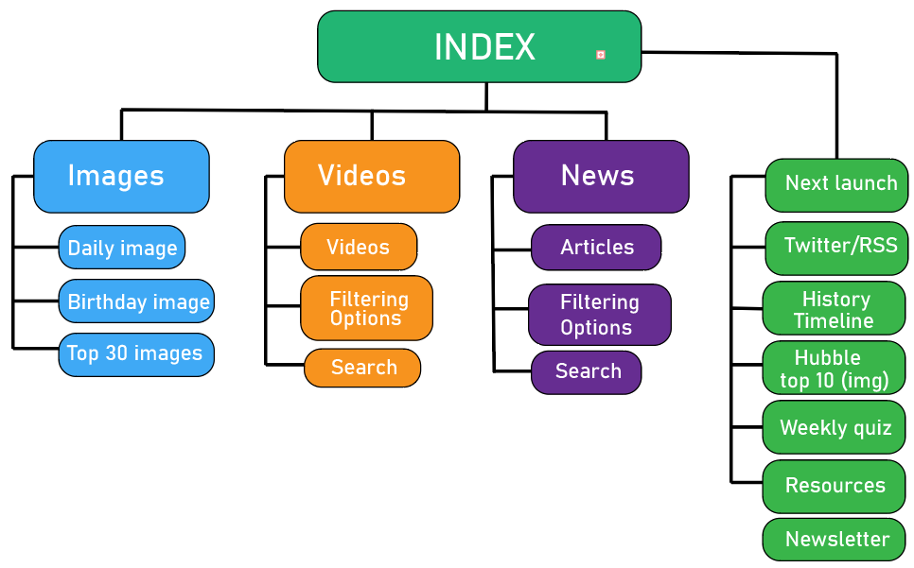

Figure 6 - [Wireframe#1]:

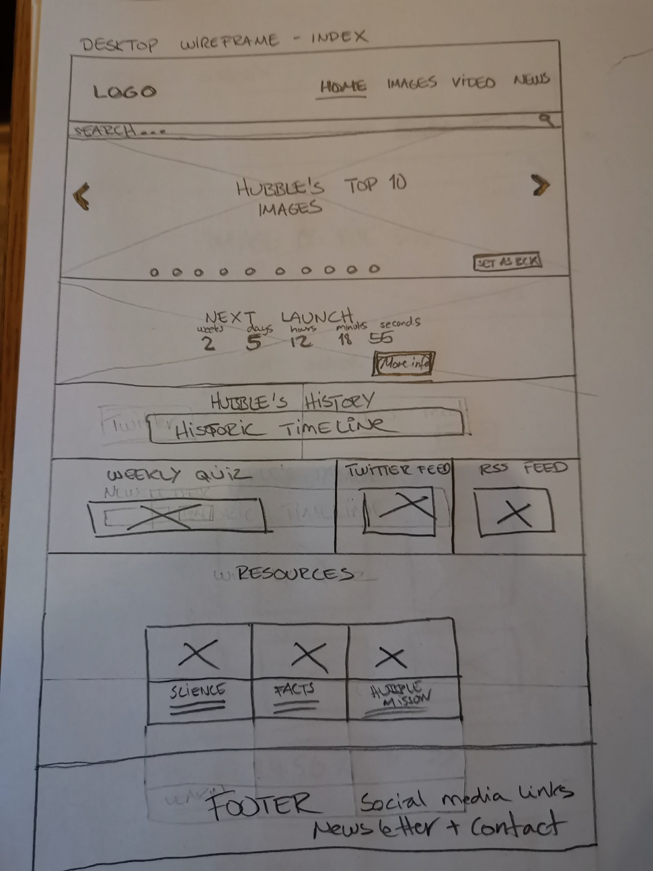

Figure 7 - [Wireframe#2]:

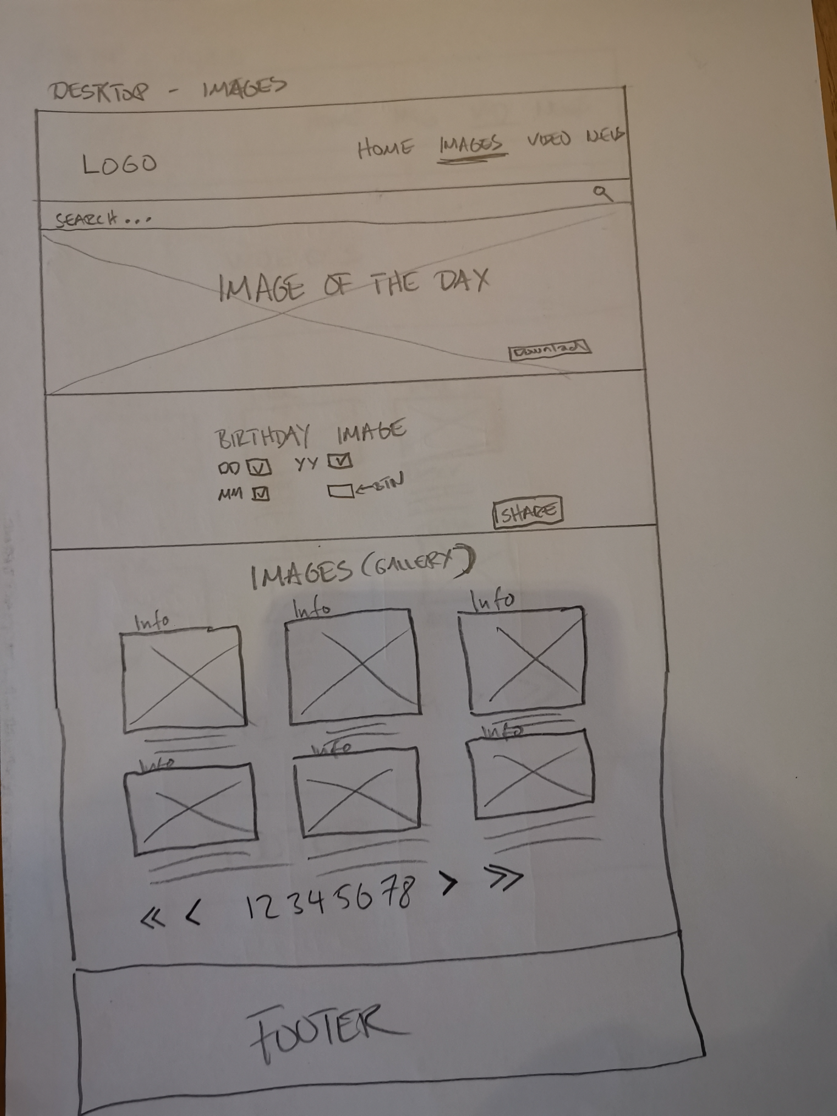

Figure 8 - [Wireframe#3]:

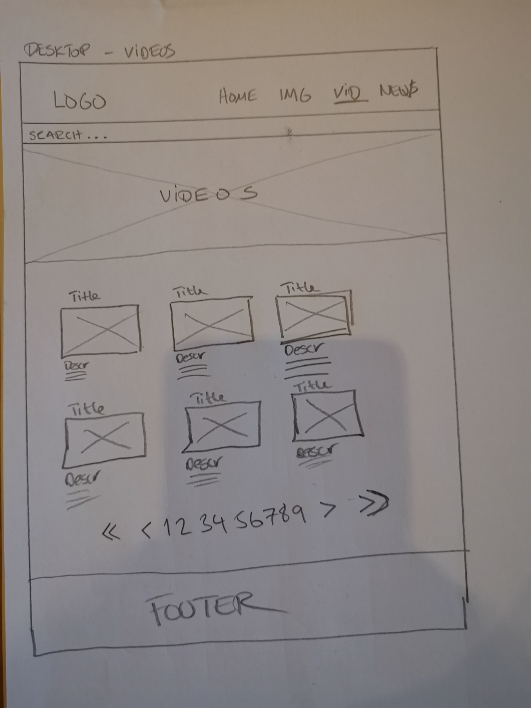

Figure 9 - [Wireframe#4]:

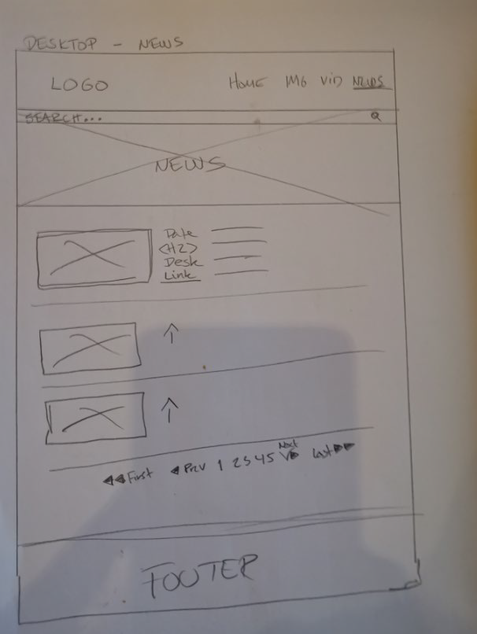

Figure 10 - [Prototype – Home Page]:

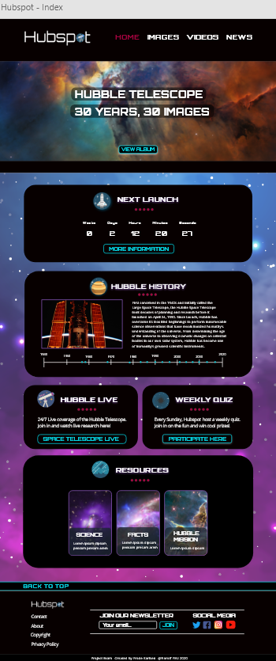

Figure 11 - [Prototype – Images Page]:

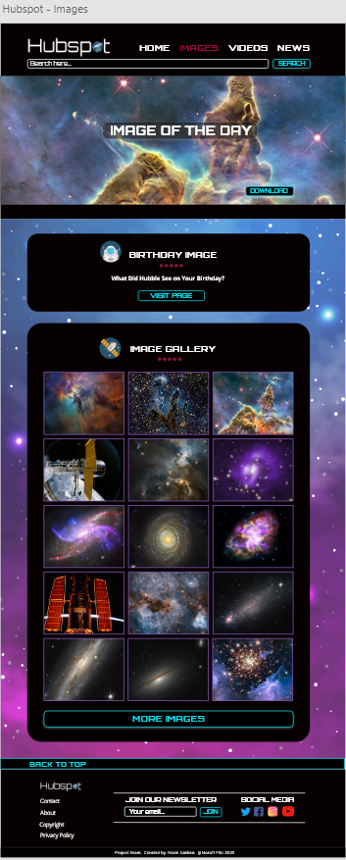

Figure 12 - [Prototype – Videos Page]:

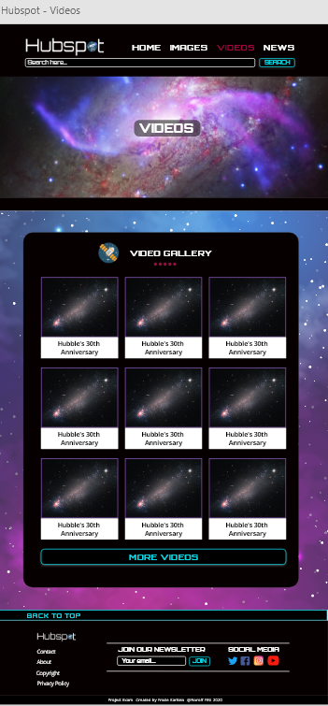

Figure 12 - [Prototype – Contact Page]:

